Ideation Phase
Define the Problem Statements

Date | 31 January 2025
Team ID | LTVIP2026TMIDS80646
Project Name | Dog Breed Identification using Transfer Learning (VGG19) with Flask Deployment
Maximum Marks | 2 Marks

Example:

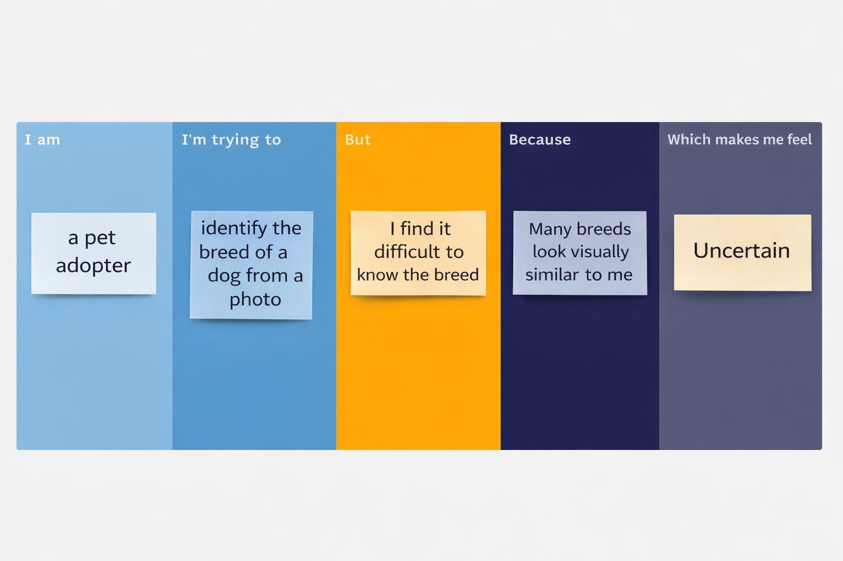

Problem Statement (PS) | I am (Customer) | I’m trying to | But | Because | Which makes me feel
PS-1 | A pet adoption volunteer | Identify the breed of a rescued dog | I’m unsure about the breed | Many dog breeds look visually similar | Uncertain
PS-2 | A pet owner | Find my dog’s breed from a photo | I get incorrect guesses | Manual identification is subjective | Confused

